AOI22 Using CMOS
Introduction:
AOI22 stands for compound gate AND OR INVERTER_2_2.
Output Y = ~(A.B + C.D) where ~ represents NOT/ INVERTER
In nMOS network contains A, B and C, D in series and both the branches are connected in parallel to represent OR gate. In pMOS network, AND gates are replaced by OR gates and OR gates are replaced by AND gates. nMOS network pulls down the network to logic 0 since, nMOS acts as a perfect switch for passing 0 and pMOS network is used to pull up the output to logic 1 as pMOS is a perfect switch for passing logic 1.

Circuit Diagram:
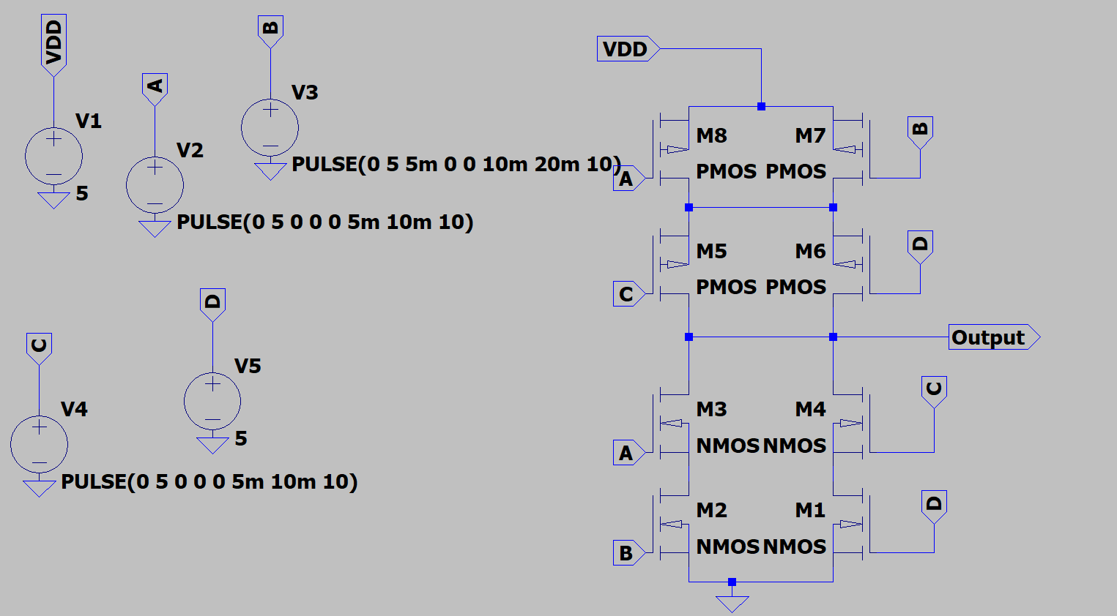

This simulation is performed on LTSpice.
Circuit contains 4 pMOS transistors (upper network) and 4 nMOS transistors (bottom network).
To obtain the nMOS configuration we consider the Boolean expression without negation. i.e. ~(AB) as AB. For, OR gate we connect the nMOS in parallel and for AND gate we connect nMOS in series.
For pMOS configuration, we negate the Boolean expression. ORs are replaced by ANDs and ANDs are replaced by ORs. In this way final circuit is obtained.
Inputs A,B and C are driven by pulses with different time periods, duty cycle is kept at 50%. Logic level HIGH is set to 5V for each input. Input D is driven by logic HIGH.

Simulation Result:
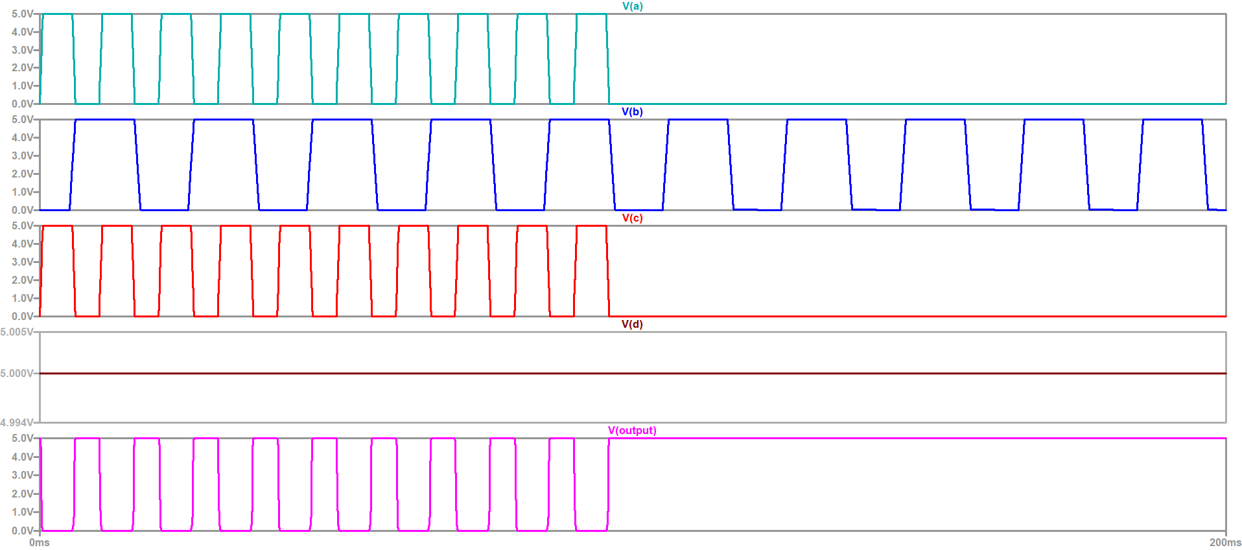

Author:
MADHUSUDAN

